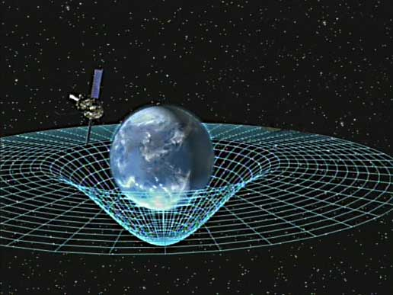Team name: Valorous

Gravity: A force that attracts two objects together. The bigger an object is, the stronger its gravitational pull is. For example, Jupiter has a stronger gravitational pull than the Earth. This is because Jupiter is more massive than Earth, thus having a bigger mass, and stronger gravitational pull.

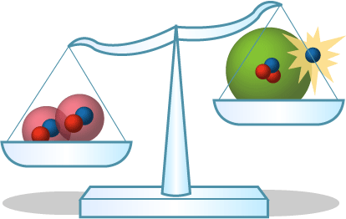

Mass: The amount of matter in an object and is usually measured in grams. For instance, the average apple is about 80 grams.

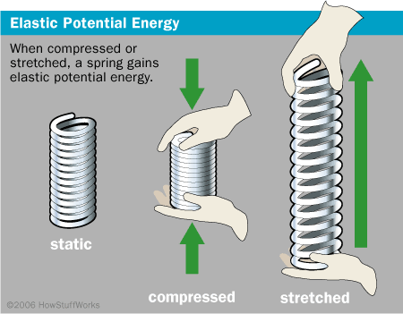

Potential/Kinetic Energy: Basically, potential energy is stored energy, and kinetic energy is the energy of motion, or the amount of energy an object has because of motion. An example of an object that obtains both traits is a coiled spring. It holds potential energy when it is compressed but releases kinetic energy when stretched.

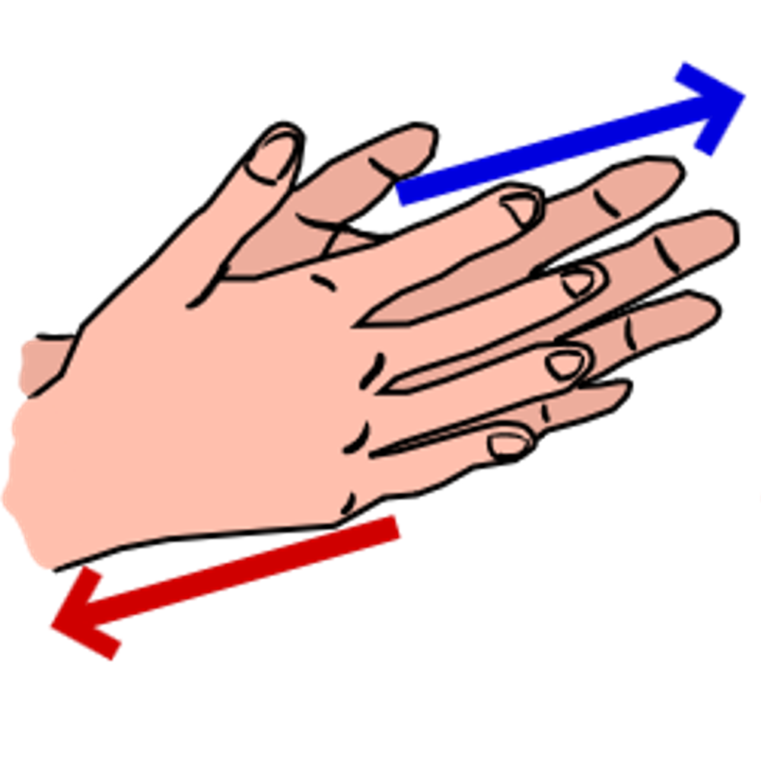

Friction: A force when two objects or surfaces exert on each other when they are rubbed against each other. For example, when you rub your hands together, you create friction with your hands.

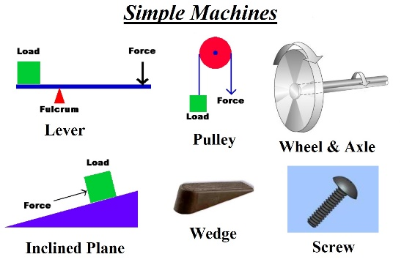

Simple Machine: A basic mechanical device for changing or applying the magnitude or direction of a force.

Examples of Simple Machines that would help us with our project:

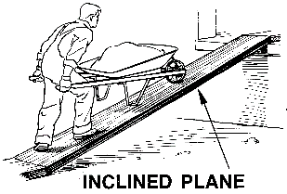

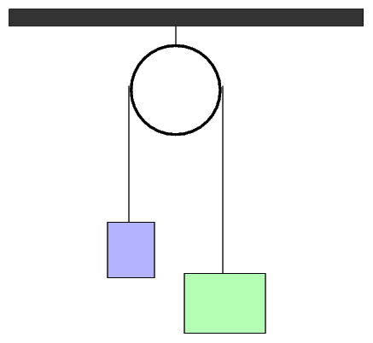

[This Photo](http://spiff.rit.edu/classes/phys369/workshops/w4r/atwood.html) by Unknown Author is licensed under [CC BY-SA-NC](https://creativecommons.org/licenses/by-nc-sa/3.0/)